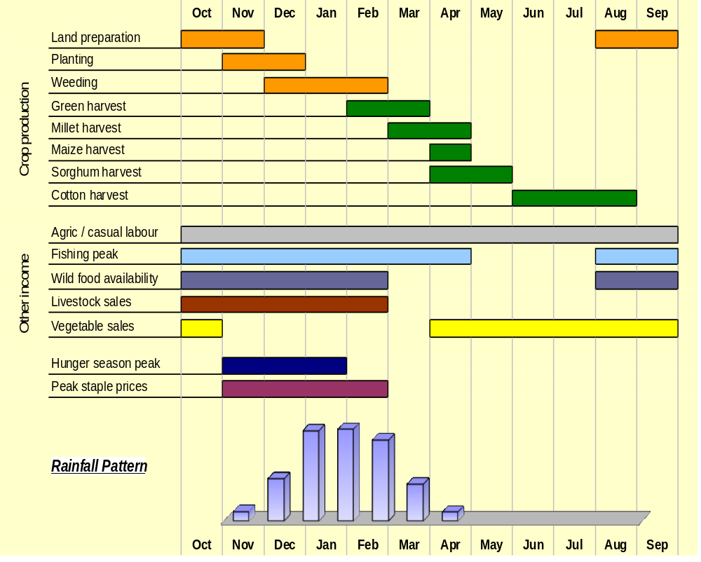

Module 2: Baseline Assessment

Session 7: Seasonal calendars

Handout 1 – Seasonal Calendars

What are seasonal calendars?
A seasonal calendar is a graphic representation of key production and market-related activities as well as other relevant seasonal events, allowing for the presentation of multiple concurrent events.

Seasonal calendar example 1: Gwembe Valley Livelihood Zone, Zambia

Why do we need seasonal calendars?
Seasonal calendars are necessary for three reasons:

- They are the basic device for storing and analysing information on seasonal variations in food, income and expenditure

- They provide a useful tool for information collection in general, because they tend to get informants involved and can help people open up and feel more comfortable. They convey information that everyone (literate and non literate) can understand and assess, and can encourage the participation of a wide group of informants.

- They provide a useful cross-check on annual food and income. Breaking things down and adding them up again can add confidence and reliability to your results.

All aspects of a household economy are influenced by seasonality, and understanding and documenting seasonal variations is necessary to:

- Understand food and income access for different groups in different seasons of the year.
- Understand when different crops are produced in a livelihood zone by different wealth groups – when they are planted, eaten green, harvested, sold, and stored.
- Identify and monitor trends and changes over time.
- Determine which indicators are useful for monitoring seasonal food access.
- Discover correlation and connections between different seasonal patterns (such as precipitation, income and expenditure; health risks and food shortages; labour crunch times and expenditure peaks) which might help to understand causes and effects.
- Reveal periods when production and consumption are unequal (when income - expenditure = debt).
- Highlight potential competition in terms of things like labour or expenditure requirements.
- Identify the most problematic times (hunger times) when stocks are exhausted and when households have difficulty purchasing food (because of little income, limited market supply, high cereal prices, low livestock prices etc.).
- Determine the immediate effect of a shock on seasonal access depending on when it occurs in the year.
- Determine the medium-term effect of a shock given how people will be able to make up for losses in subsequent seasons, depending on when the shock occurs in the year.

When should a seasonal calendar be constructed?
As with much of the information gathering work in HEA, constructing a seasonal calendar is an iterative process. Start with as much secondary data as possible, and then add details and accuracy as you gather more information in the field.
However, be prepared to find differences between the information you obtain in the field and that obtained from secondary sources. This may be because the seasons have in fact changed since the document was written; or it may be that the secondary information was never actually checked in the field. Try and reconcile these differences by checking your field data and asking questions as much as possible. But if these differences are irreconcilable, you should, as a rule of thumb, tend to trust what you are repeatedly told in the field over what you find from a secondary source.
- Try and find as much information on seasonality as you can from secondary data or key informants in the capital city before you go to the field.
- If your key informants are knowledgeable enough, start constructing a livelihood-zone specific seasonal calendar at district level.
- Add to and revise your calendar through interviews with community leaders.
- It is helpful to use a seasonal calendar during the interviews with household representatives from different wealth groups, in order to check that results are consistent and to obtain additional detail.

Do not be surprised if the seasonal information gathered from secondary literature does not directly correspond to what you find in the field. There are a number of reasons for this:
- The mis-match between administrative boundaries and livelihood zones;
- A noticeable shift in seasonality over the past decade due possibly to climate change;
- Inaccuracies in aggregate surveys compared with more accurate local knowledge.
For the most part, if the local seasonality appears consistent between interviews, it should be given more weight.

How do you construct a seasonal calendar?
Seasonal calendars can be constructed in a number of ways. They can include any number of topics, such as harvest and planting times, sales of livestock, purchase of grain, activities per wealth group/per household member, movement to grazing lands, peak fishing times, sickness among children, etc.

Sources
Secondary sources: When gathering information from secondary data before going out to the field, record any significant details referring to the seasonality, events or activities of the livelihood zone. In this way you can start to build up a seasonal picture.

District key informants: Calendars will first be constructed with key informants at the district level before visiting the villages to confirm. You can work together with the key informants by drawing out the months and identifying their seasons on a piece of paper. Having identified the seasons, fill in details of when different activities, rainfall and events occurred during the period under study.

Village interviews: Define the seasons with the group participants, trying to match them with the information you have gathered so far. You can either note the seasonal calendar in your notebook, on a flip chart on the ground or mark out a line on the ground with the group, using objects to represent different activities. Go through the seasons discussing and identifying the different activities for each period.

How to do it
Seasonal calendars can be constructed in the same way as a community map, using local materials such as sticks, stones, leaves, branches, bricks and rocks. So you need first of all to gather together these materials. Alternatively, you can use flipchart paper.
- Begin by defining the seasons in that area. Try to match seasons to the Gregorian calendar, but use local names in discussion if relevant.
- Place items representing the seasons horizontally along the bottom of the paper or the ground.
- Down the side - in the ‘vertical’ column - list activities or items according to the type of calendar you are trying to construct, such as rainfall, weeding, planting, migration for employment, livestock sales.
- Begin the discussion by asking informants when an activity normally takes place. Establish when it begins and ends. Mark the period on the ground or paper with materials collected.
- During this process you should also establish who is doing the activity. Make sure age and gender are specified.
- Continue asking questions until you have exhausted the list in the vertical column.
- Summarise findings and clarify any outstanding questions with informants before ending the interview.

Seasonal calendar example 2: An irrigated farming livelihood zone (Dawa-Ganale Riverine Livelihood Zone), Somali Region in Ethiopia

